615 N. Alabama St, Suite 134, Indianapolis, IN 46204
2015-2016
CACFP Sponsorship Management Plan; Policies and Procedures
Contract Year October 1, 2015– September 30, 2016
Child Care Answers Child and Adult Care Food Program

Table of Contents
Contents
Introduction - 2 -
Eligibility Guidelines - 3 -
Pre-Approval Process - 4 -
Provider Reimbursement, Claim Submission and Tiering - 5 -
Claims - 7 -
Training Requirements - 8 -
Record Keeping Requirements 1
Meal Service 2
Monitor Visits 3
Warning Letters, Seriously Deficient Procedures 5
Seriously Deficient Procedures: 6
Termination 7
Appeals 8

Introduction

Early Learning Indiana is an advocate for quality early childhood programs throughout Central Indiana. In addition, Early Learning (Child Care Answers) is a sponsor of the Child and Adult Care Food Program (CACFP) in Central Indiana. CACFP is a federally funded program organized by the United States Department of Agriculture and the Indiana Department of Education. CACFP sponsors offer training, technical assistance and cash reimbursement to licensed family day care homes and certified legally exempt child care homes for serving nutritious meals to children in their care. There is no fee to participate. The following document contains policies and procedures for the Child Care Answers CACFP Sponsorship.

Contacts:
Mindy Bennett, Program Director; mindyb@childcareanswers.com
Molly Manley, CACFP Coordinator; mollym@childcareanswers.com
Emily Barrow, CACFP Monitor; emilyb@childcareanswers.com

Phone Number: (317) 636-5727 Ext. 228
Fax: (317) 687-6248

615 N. Alabama St, Suite 134
Indianapolis, IN 46204

Website:
www.daynurserycacfp.weebly.com
www.childcareanswers.com

“The UDSA and the State of Indiana are equal opportunity providers and employers”

Eligibility Guidelines

In order to participate in CACFP, the provider must be one of the following:
- A licensed child care home
- A legally exempt provider that has met the provider eligibility standards

Child Care Answers reserves the right to deny a provider for any of the following reasons:
- The provider is not in good standing with the Indiana Family and Social Services Administration.
- The provider’s name or anyone working with the provider name is on the National Disqualification List.
- If the provider left another Sponsoring organization and was not in good standing with them.
- If the provider is currently enrolled with another Sponsoring organization.
- If the provider was previously sponsored with Child Care Answers and left the program with unresolved corrective action.

Child Care Answers reserves the right to inquire with other Sponsoring organizations regarding enrollment and possible serious deficiency status for the provider seeking to enroll with Child Care Answers CACFP.

Child Care Answers Child and Adult Food Program does not accept or work with any providers that have been placed on the National Disqualification List.

Pre-Approval Process

To sign on with Child Care Answers Child and Adult Care Food Program the following steps must be followed:
- The provider has received in the mail a copy of their Child Care License or copy of the Provider Eligibility Checklist. (We cannot sign a provider on until they have received the paper copy of their license)
- Child Care Answers CACFP staff will complete an intro/preapproval meeting with the interested provider.
- Once the preapproval has been conducted the provider must complete the required new provider training. This includes training in Record Keeping, Meal Planning, Seriously Deficient, and Minute Menu.
- When CCA staff receives the completed training the provider will be eligible to begin claiming on the program. If the provider will not begin claiming right away a date will be set they intend to claim.

During the pre-approval meeting the Sponsor will review all the program requirements the following criteria must be understood/agreed by the provider prior to claiming on the program:

- They must follow all CACFP Guidelines for Food Service, Nutrition and Sanitation
- Maintains Basic CACFP Record Keeping Forms
- Agree to completing 6 hours of annual training provided by the Sponsor
- Agrees to a minimum of three(3) unannounced monitor visits per contract year
- Post the civil rights posters, notify families with the Building for the Future handout and distribute WIC brochures.
- Claims will be submitted in a timely manner and paid via direct deposit. Any provider that does not submit a claim in a two month time period will be removed from the program.
- Provide a copy of the child care license or provider eligibility standards for CCA records and submit a direct deposit form.
- Set a date in which the provider will begin program operations. Until a date is given the provider will remain on hold.

If the site being signed on is under an owner with multiple licenses, both the license holder and the provider must sign the paperwork.

If during the pre-approval visit it is determined that the provider is out of compliance with regulations as defined in licensing or certification such as; health, safety and/ or sanitation issues, and/or the food preparation area and food service equipment is not adequate, the provider will be advised that the non-compliance(s) must be resolved prior to being approved for participation in the CCA CACFP program. The provider will receive a follow-up letter for the program coordinator outlining the non-compliance issues and the corrective action steps needed prior to the application being approved. A follow up visit will then be scheduled within two weeks after the initial pre-approval visit to ensure that any and all non-compliances have been resolved.

Once the provider has completed the pre-approval process they will then be eligible to participate in the CCA CACFP program. CCA will enter the provider information into the Department of Education’s database and into Minute Menu. The provider will then receive electronically their username and password for the program.

Provider Reimbursement, Claim Submission and Tiering

At the time a provider enrolls in the food program, their reimbursement rate will be determined using a two-tiered means test.

Tier I
Providers may qualify for the higher (Tier 1) reimbursement rates if they meet one of these criteria:
- The school the provider’s children would attend has 50% or more children eligible to participate in the free or reduced USDA program. A provider that meets Tier 1 criteria by this means is eligible for a 5 year period.
- The area in which the provider lives is considered under the 185% of the poverty level based on the latest census data as well as the school free or reduced meal participation for the school their child would attend is 40-50%. A provider that meets Tier 1 criteria by this means is eligible for 5 years.
- Their own family income. Providers can submit a free/reduced lunch application along with income verification for the entire family. Eligibility will begin the date the application and all documentation is received. A provider that meets Tier 1 criteria by this means is eligible for a 1 year period.
Tier II
If a provider does not meet at least one of the above criteria, they will receive the lower (Tier II) reimbursement rate. A provider can be determined Tier II mixed and receive a combination of Tier I and Tier II rates depending on family eligibility (refer to Tier II mixed).

Tier II Mixed
If a provider has been determined Tier II, the provider can request that all of their parents fill out an Income Eligibility Application to determine if they are eligible to have meals that are served to their children reimbursed at the Tier I rate. Day Nursery will email the provider the most current application to print and give to all parents in the program. The parent needs to complete one application to the entire family and return directly to Child Care Answers. A family’s income determination results cannot be disclosed to a provider. The provider will only know a ration. For example, Child Care Answers can tell a provider that three of the five families are eligible for Tier I rates. Parents need to renew their Income Eligibility Application annually.

Providers Own/Residential Children
A licensed or legally-exempt provider who meets income guidelines may also claim meals served to any resident children during business hours when non-resident day care children are enrolled and present at the same meal service. Income eligibility is determined by the free/reduced lunch application and documentation.

Resident Foster Children
An income eligibility application must be completed for each individual foster child residing in a provider’s home. A foster child is considered a family of one and is categorically eligible for Tier I reimbursement.

Child and Adult Care Food Program Income Eligibility Guidelines for Tier I
(Effective from July 1, 2015 to June 30,2016)
Household Size | Monthly Income
1 | $1,815
2 | $2,456
3 | $3,098
4 | $3,739
5 | $4,380
6 | $5,022
7 | $5,663

Definition of a Household
Household means a group of related or non-related individuals who are not residents of an institution or boarding house, but who are living as one economic unit. A foster child is considered a household of one.

Definition of Income
“Income” means income before deduction for income taxes, employee’s social security taxes, insurance premiums, charitable contributions, and bond, etc. It includes the following:
- Monetary compensation for services, including wages, salary, commissions or fees
- Net income from self-employment
- Social security, public assistance, welfare, alimony or child support payments
- Dividends or interest on savings bonds, income from estates or trusts or net rental income
- Unemployment compensation
- Government civilian employee, or military retirement, or pensions or veterans’ payments
- Any other cash income

Claims
Child Care Answers provides a monthly reimbursement to providers in accordance with the rules and regulations of the Child and Adult Care Food Program.

Daily Reimbursement Limitations
The USDA limits daily reimbursement to two meals and one snack or two snacks and one meal per child per day. However, it is advantageous to the provider to record all meals served. The Minute Menu system will automatically claim the most financially advantageous combination of meals claimed. In addition, when a meal is disallowed due to a mistake in paperwork the computer can then reimburse for another meal. All meals disallowed are tracked and totaled on an end of the year tax report to assist providers at tax time.
For example, if a provider offers a child breakfast, am snack, lunch, pm snack and dinner, the
Provider will be reimbursed the highest combination – which is lunch, dinner and one snack. If
the lunch was disallowed because it did not meet USDA guidelines it would not be reimbursed
but the computer would pay for breakfast instead. All non-reimbursed food expenses may be
used as a tax deduction.

The following procedure will be followed for claim submission:
- Monthly claims are due to Child Care Answers by the 5th of each month. Claims turned in after the 5th of each month may not be processed until the following month. Claims turned in after forty (40) days from the last day of the month will not be reimbursed. These claims are not accepted by the Department of Education.

- All paperwork MUST be turned into Child Care Answers by the 5th of the month. This included pending enrollment forms , special diet forms, direct deposit forms, and child care licenses.

- Child Care Answers processes the claim information and submits it to the Department of Education by the 10th of each month.

- The Department of Education has forty-five days (45) days to process the claim and submit reimbursement to Child Care Answers. Child Care Answers will distribute reimbursement dollars, via direct deposit, within five days of receiving the funds from the Department of Education.

- Claims will be held until a monitor is able to complete a successful four week visit

- The dollar amount of the provider’s food program reimbursement is based on the providers tiering status (refer back to tiering determination)

Rates of reimbursement July 1, 2015-June 30, 2016
Tiering Level | Breakfast | Lunch/Supper | Supplements
Tier I | $1.32 | $2.48 | $.74
Tier II | $.48 | $1.50 | $.20

Child Care Answers reserves the right to reject any claim or portion of a claim that is believed to be invalid. This is not a “suspension” but a denial of a claim based on the normal claim review process.

Training Requirements
All Child Care Answers CACFP providers must ensure that their staff is completely trained in all aspects of the CACFP program. Including but not limited to; how to handle civil rights complaints if they are received, how to mark meals at point of service, meal pattern requirements and components, and proper sanitation.
Child Care Answers CACFP providers must complete a total of 6 hours of annual training. In addition to the annual training the provider and all staff members must complete civil rights training. Failure to complete training in the timeframe may result in the provider going into serious deficient status.

Training for the 2015-2016 contract year will be offered once in person on Saturday, November 7, 2015 from 9am-3pm. Providers must pre-register for the training by emailing their monitor. (Spanish trainings will be offered face to face, dates still to be determined)

If you are unable to attend the in-person training, a training packet is available online at www.daynurserycacfp.weebly.com . Should you be unable to print and complete the packet, you may request a packet to pick up at the office. If you are requesting a packet please give us 24 hours’ notice.

Record Keeping Requirements

In order to stay in good standing with Child Care Answers CACFP providers must adhere to following record keeping guidelines:
- Minute Menu will be used for all record keeping, menus and claims.
- Provider will schedule a menu in Minute Menu, at least weekly, prior to the start of the business week and post the menu in a public location.
- If a provider serves infants they will create a weekly, dated infant menu and post in a public location.
- Any changes to the scheduled meal will be changed on the menu at least 15 minutes prior to meal service. Failure to make changes on the posted menu will result in the meal being disallowed.
- Provider will record all meals at point of service. Child Care Answers defines point of service as after the children have washed their hands and sat down at the table and before they leave the table after eating. Meals may be recorded on the weekly attendance worksheet and entered into Minute Menu weekly or immediately into Minute Menu.
- If meals are not recorded immediately into Minute Menu they must be recorded AT LEAST weekly into Minute Menu.
- Building for the Future, WIC information and the Justice For All Posters displayed
- Building for the Future flyer and WIC information in your parent enrollment packet
- The provider will have on site the following documents in an organized manner:
  - Current copies of the permanent enrollment forms for all children enrolled. These must be signed by both the parent and the provider and be the original signed document (a copy is not acceptable at the site)
  - Re-enrollment forms for the past three years
  - Current annual agreement plus the past three years.
  - Permanent agreement
  - Tiering determination letter
  - Signed management plan for current year, plus three previous years
  - Copies of training certificates
  - Copies from monitor visits

Provider must maintain at the child care site three (3) years’ worth of ALL CACFP records. These records must be organized and available for a monitor review. All paperwork should be accessible to all staff. This will ensure the monitor will be able to complete the visit even if the provider is out. If the site has not been on the program for three (3) years then the provider must have all CACFP records since the date the program signed on.

Meal Service
Meal Times
Meals must be served in the timeframe that was set during your pre-approval appointment. If you wish to change your meal service time you must notify Child Care Answers in writing. Changes to the times will not apply until the following month after your request is received. For example, if you write to Child Care Answers August 15th that you wish to change you breakfast time the request will not go in effect until September 1st. This is so that monitors have time to plan scheduled visits during your meal times.

If you claim meals on a weekend or a holiday you must submit the weekend/holiday form along with your claim. The form can be found online at www.daynurserycacfp.weebly.com

Holidays
Providers wishing to claim the following holidays must notify the sponsor one week prior to the holiday. The provider may not notify the sponsor earlier than a week prior. A sign in and out sheet will be required for the holiday and must be submitted with the claim.
- Christmas Day
- New Year’s Day
- Easter
- Fourth of July
- Memorial Day
- Labor Day
- Thanksgiving

Field trips, vacations, etc
If you will be off site during normally served meals you must notify Child Care Answers. Meals served offsite cannot be claimed or reimbursed. If you will be closed for a vacation, holiday, etc. please make sure you have notified your monitor.

Sanitation
Proper health and safety procedures must be followed during meal service. This includes sanitizing the table and ensuring children wash their hands both prior to and after meal service. Children must go directly from washing their hands to the sanitized table. The bleach solution must be made fresh daily and paper towels must be used when sanitizing table and drying children’s hands.

Meal Components
- All meal components must be served at the time of meal service.
- USDA requires each meal to contain selections from the five groups; breads, fruit, vegetables, meat/meat alternatives and milk. Specific portion sizes are required depending on the age of the child. These guidelines are outlined in the two food charts; one for infants under 12 months and one for children 1 to 12 years of age.
- Providers must develop their own menus according to these nutrition guidelines and schedule them into Minute Menu. Templates of pre-created menus are also available in Minute Menu. Menus should reflect a variety of low fat, low sugar, low sodium foods.
- Juice should be limited to two to three times a week and must be 100% fruit juice.
- Children between the ages of 12 months and 23 months may be served 2% or whole milk, children over the age of 23 months may have 1% or skim milk. Please be aware of this and make sure you have enough milk on hand for all age groups to get through the business day.

There must be enough food at your site to complete all meals scheduled for the day. Lack of food available for the day will result in meals being disallowed for the day. We recommend you have enough food on site for the entire week.

Monitor Visits

Based on the daily meal service schedule submitted by the provider, the Child Care Answers CACFP Monitor will visit each provider at least three (3) times per year. These visits are to monitor food service, sanitation practices, and record-keeping practices.

During each monitor visit the monitor will:
- Check to ensure that the provider has posted:
- Current child care license or certification
- The non-discrimination posters (Justice For All and Building for the Future) flyers are posted in a visible location
- Current menu for the week is posted with any menu substitutions written clearly on it. **Remember unless you are a scan provider your menu MUST be printed off of Minute Menu
- Infant Menu is dated and posted if you care for children under the age of
- Check to ensure the following is on file:
- Permanent enrollment form for each child in your care is on file and signed by both the provider and parent, these must be the originals
- Re-enrollment forms are signed and on file. (You must keep 3 years of these)
- Parent packet includes the Building for the Future flyer and WIC information
- Contracts for the current year plus three (3) previous years
- Signed management plan for current year plus three (3) previous years
- Permanent agreement and tiering letter

- Check to ensure health, safety, and sanitation procedures are followed. This includes hand washing, proper table sanitation, and temperatures of the refrigerator, that the cooking area is clean.
- Check to ensure that the correct menu items are being served and follow the quantities outlined in the food charts.
- Check to ensure meal is served during the approved meal time and at the approved location.
- Check enrollment and attendance numbers on the day of the service.
- Complete a 5-day reconciliation of providers enrollment and attendance records. The monitor will examine the meal count recorded for five consecutive days during the current and/or prior claiming period and reconcile meal counts to both attendance and enrollment by child. For each day examined, the monitor must use enrollment and attempt to reconcile those numbers of breakfast, lunches, suppers, and snacks recorded. Based on that comparison, monitor must determine whether meal counts were accurate.
- Check to ensure the signed Monitor/Provider agreement is posted in a visible location

Four Week Monitor Reviews
Providers are required to have a four week monitor review after they begin the program. The provider is responsible for notifying the sponsor when they will begin program operations during their pre-approval. If the provider is unsure of when they will begin they will be placed on hold until they notify the sponsor of their start date.

Treatment of Monitor during Review
Please keep in mind your monitor is conducting your visit based on standards and requirements you have agreed to when signing your contract. Please treat your monitor with respect and provide the required information and paperwork to them during your monitor visit. Providers are required to sign the visit form at the end of the visit. Providers who are disrespectful, rude, unwilling to cooperate, or make the monitor feel threatened will be made seriously deficient.

The following procedures will apply when an attempted unannounced visit fails:
- If no one answers the door or no one is home: The meals for the ENTIRE day will be disallowed.
- Provider has already served meal or is not claiming specific meal service: The monitor will check all CACFP paperwork, complete as much of review as possible and confirm serving times. If the meal was served outside approved meal time the meal will be disallowed.
- Provider is running behind and serves meal after the approved meal service time or children arrive after the meal service time: The meal may still be served but it may not be claimed. If provider attempts to claim the meal that was served after the approved time it will be disallowed.
- No child care children are present at meal service: The meal will be disallowed. The monitor will check CACFP paperwork, document provider’s explanation of cause and conduct a follow up visit.
- CACFP record keeping forms are not complete/up to date: Meals served that are not properly or completely documented at point of service will be disallowed. Monitor will assist provider in updating forms and conduct a follow up visit.
- Number of claimed meals for the day prior to visit does not coincide with number of children present at a review: Monitor will complete the review and conduct a parent audit on the enrolled children via telephone or mail. The information from the audit is documented, compared to the provider’s claim for the corresponding month and kept on file. Any necessary adjustments and/or actions as a result of the audit will be taken at that time.

Meals will be disallowed for the following reasons during a monitor visit:
- The incorrect milk is being served or the provider does not have required milk on hand. This will result in one week’s worth of meals being disallowed.
- If the current weekly menus (infant and regular) are not posted, the observed meal will be disallowed. Menus must be entered into Minute Menu at the start of the business week. If you need assistance please contact the office.
- All required components for the observed meal are not served at the same time the meal will be disallowed.
- If the meal is missing required components the meal will be disallowed
- If meals are not documented at point of service ALL meals not documented will be disallowed.
- Two visits during a twelve month time period in which the monitor notes low enrollment compared to the five day reconciliation will result in the provider being required to complete sign in and out sheets as provided by the CACFP staff. The sheets must be completed and turned in with each monthly claim until further notice.

Providers will be reported to the Indiana State Licensing Department for the following:
- Provider is over licensed capacity
- The monitor determined that there is a health and safety concern in your facility.
- The monitor has an immediate concern about the well-being of the children in your care emergency services will be called immediately and the State Licensing department will be notified.

Warning Letters, Seriously Deficient Procedures

Warning Letter: Second occurrence of provider deficiency
Providers who are out of compliance with the CACFP rules and regulations during an attempted monitor visit will receive via email a written letter of warning stating the deficiencies and steps to correct the issue. Providers must respond in writing within five (5) days of receiving the written warning a plan of action to make sure the deficiencies are corrected as well as an understanding of CACFP policies. Failure to send in the written action plan will result in the provider being declared seriously deficient.

Seriously Deficiency: After multiple provider deficiencies
Providers who have been warned, submitted a corrective action plan, and still fail to follow all CACFP rules and regulations will be determined seriously deficient.

The following items may result in the provider being declared seriously deficient:
- Submission of false information on CACFP applications or forms
- Submission of false claims for reimbursement
- Simultaneous participation under more than one sponsoring organization
- Non-compliance with CACFP meal patterns
- Three disallowances in a two year period due to meal review discrepancies
- Failure to keep required/ accurate records
- Failure to notify CACFP when a provider will not be home for a meal as approved
- Failure to complete the 6 hours of annual training per contract year

Types of Audits that may occur:
- Additional unannounced visits
- Limited Household contact: Day Nursery contacts the parents of enrolled children to determine child’s attendance (including day, hours and meals) for the previous five days.
- Complete household contact: Day Nursery contacts the parents of enrolled children to determine child’s attendance for the previous month and general schedule (days, hours).
Providers must ensure we have accurate contact information for the children enrolled in their care. Please include email address and phone number for at least one parent of each enrolled child
Corrective Action
A corrective action must ensure prompt and permanent resolution of the problem(s) and must be completed within 10 days or less. If the provider completes the appropriate corrective action in the period specified, the notice of seriously deficient will be rescinded. Should a provider ever have the same problem(s) occur at any time the provider will go straight to propose to terminate.

Seriously Deficient Procedures:
A provider not in compliance with Child Care Answers Sponsorship and /or CACFP rules and regulations, as determined by CACFP Coordinator, is notified in writing of the non-compliance and the actions that must be taken to correct the issues or concerns. This notice serves as a letter of warning and gives the provider ten (10) working days to make corrective actions. A follow-up visit will be conducted after 10 days if necessary.

If the provider has not taken corrective action, Child Care Answers will begin the Seriously Deficient Process. A written notice that the provider is seriously deficient in the operation will be sent outlining the steps necessary to avoid any future negative action. If based on a review and/or audit it is determined that the deficiency in the operation of the child and adult care food program has not been fully and permanently corrected, Child Care Answers will propose to terminate the agreement and disqualify the provider from future CACFP participation. A letter of “Intent to Terminate” will be sent to the provider via registered mail. In addition, voluntarily of the agreement after receiving the “Intent to Terminate” will not stop the process of proposing to terminate and disqualify the provider from future CACFP participation.
If disqualified, the provider’s name will be placed on the National Disqualification List. While on the list, the provider will not be able to participate in the CACFP as a day care home provider. In addition, the provider will not be able to serve as a principle in any CACFP institution or facility. The providers name will remain on the list until such time as the State Agency determines that the serious deficiencies have been corrected(a minimum of three (3) years), or until 7 years after the disqualification. However, if any debt relating to the serious deficiencies has not been repaid, the name will remain on the list until the debt has been paid.

Termination

The following are a few reasons a provider may be terminated from the program for cause:

- If a provider has been determined to be seriously deficient and no corrective action has been taken.
- Providers who are cited by state and local agencies for health and/or safety violations
- Provider has been convicted of defrauding a federal or state program

When the Day Nursery CACFP monitoring staff determined that children in the day care home face an imminent threat to their health or safety, or when the day care home’s activities pose a threat to public health or safety; Day Nursery may immediately suspend program operation without providing the day care home the opportunity to take corrective action. Day Nursery must still offer the day care home its right to appeal, but shall not make program payments during the appeal process.

Providers are immediately terminated from the program without prior notice for causes such as ABUSE or NEGLECT of a child, or loss of LICENSE.

Appeals

A provider terminated from the program has the right to appeal. Appeals must be submitted in writing within ten (10) days of receipt of letter of intent to terminate for just cause to:

Child Care Answers Appeal Officer

615 N. Alabama Street, Suite 300

Indianapolis, IN 46204

The appeal should include why you believe you should not be terminated and any evidence that you have to support why you should not be terminated.

Child Care Answers will provide the documentation that you submit along with any documentation that they have used to determine that you should be terminated to the Child Care Answers Officer. The Appeal’s Officer will then rule on the case within thirty (30) days. You will be informed of the decision in writing as soon as it has been issues.

Child Care Answers Appeals Officer is an individual that has been trained in CACFP rules and regulations. The officer is an individual that is not involved with the day to day operation of the CACFP home program.

During the appeal proves program payments may continue for claims supported by appropriate documentation.

Any provider who is terminated from the Child Care Answers CACFP sponsorship will be placed on the National Disqualification List. The provider does not have the opportunity to correct the serious deficiency(ies) in these cases.

The U.S Department of Agriculture prohibits discrimination against its customers, employees, and applicants for employment on the bases of race, color, national origin, age, disability, sex, gender identity, religion, reprisal, and where applicable, political beliefs, marital status, familial or parental status, sexual orientation, or all or part of an individual’s income is derived from any public assistance program, or protected genetic information in employment or in any program or activity conducted or funded by the Department. (Not all prohibited bases will apply to all programs and/or employment activities.)

If you wish to file a Civil Rights program complaint of discrimination, complete the USDA Program Discrimination Complaint Form, found online at http://www.ascr.usda.gov/complaint_filing_cust.html or at any USDA office, or call (866) 632-9992 to request the form. Send your complaint form or letter to us by mail at U.S. Department of Agriculture, Director, Office of Adjudication, 1400 Independence Avenue, S.W., Washington, D.C. 20250-9410, by fax (202) 690-7442 or email at program.intake@usda.gov.

Individuals who are deaf, hard of hearing, or have speech disabilities may contact USDA through the Federal Relay Service at (800) 877-8339; or (800) 845-6136 (Spanish)

USDA is an equal opportunity provider and employer.

It is the policy of the Indiana Department of Education not to discriminate on the basis of race, color, religion, sex, national origin, age, or disability, in its programs, activities, or employment policies as required by the Indiana Civil Rights Lax ( I.C. 22-9-1). Title VI and VII (Civil Rights Act of 1964).the Equal Pay of 1973, Title IX (Educational Amendments), Section 504 (Rehabilitation Act of 1973), and the Americans with Disability Act (42 USCS 12101, et seq.)

Inquiries regarding compliance by the Indiana Department of Education with Title IX and other civil rights laws may be directed to the Title IX Coordinator, Indiana Department of Education, Room 229, State House, Indianapolis, IN 46204-2798, or by telephone to (317) 232-6610 or the Director of the Office for Civil Rights, U.S. Department of Education, 111 North Canal Street, Suite 1053, Chicago, IL 60606-7204 (312) 886-8434 – Glenda Ritz, Indiana Superintendent of Public Instruction.

Sponsors Copy

Contract Year 2015-2016

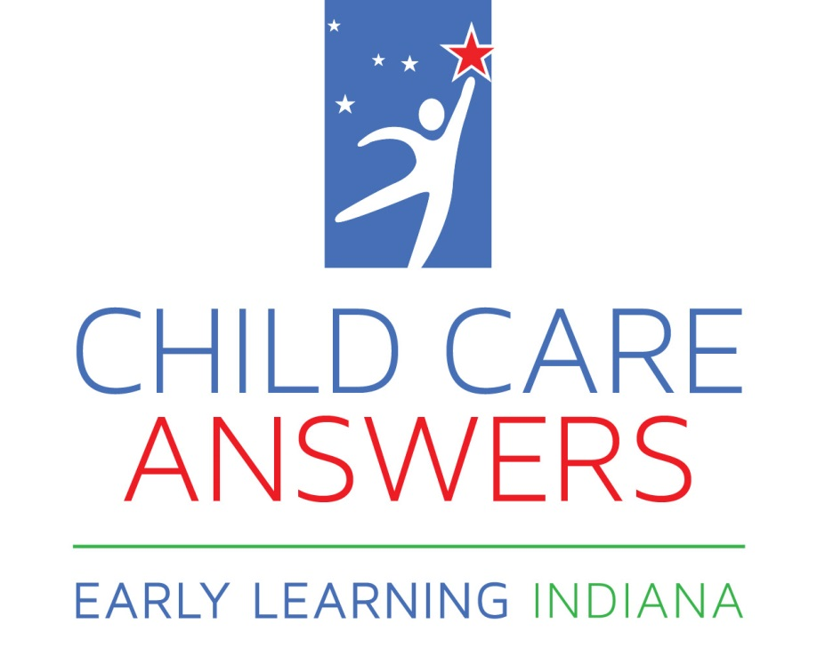

I have read and understand the Child Care Answers CACFP Sponsorship Management Plan; Policies and Procedures. Further, I agree to abide by and adhere to the aforementioned program policies and procedures.

_______________________________________________ ________________________

Provider’s Signature Date

______________________________________________

Provider’s Printed Name

“The USDA and the State of Indiana are equal opportunity providers and employers.”

Providers Copy

Contract Year 2015-2016

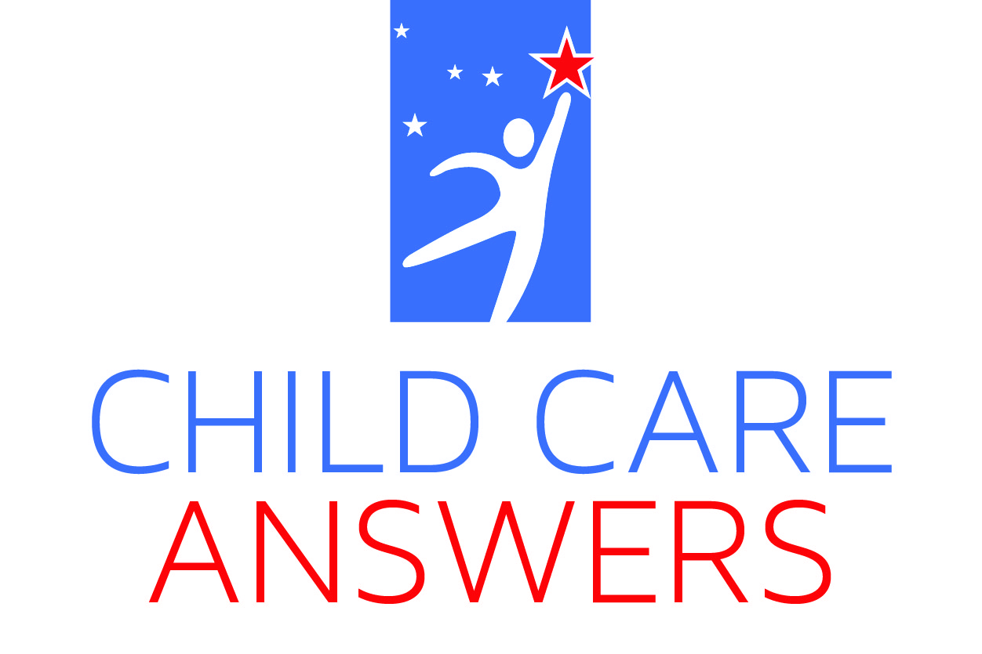

I have read and understand the Child Care Answers CACFP Sponsorship Management Plan; Policies and Procedures. Further, I agree to abide by and adhere to the aforementioned program policies and procedures.

_______________________________________________ ________________________

Provider’s Signature Date

______________________________________________

Provider’s Printed Name

“The USDA and the State of Indiana are equal opportunity providers and employers.”

